Northwind Traders Dashboard



NORTHWIND TRADERS DASHBOARD
Data Analysis and Business Intelligence Project
Submitted By: Mayuri Mukunda Jamdar
Branch :- B.Tech Artificial Intelligence & Data Science
Collage Name :- CSMSS Chh. Shahu College of Engineering, Chhatrapati Sambhajinagar

ABSTRACT
The Northwind Traders Dashboard project is developed using SQL, Microsoft Excel, Power BI, Power Query, and DAX to analyze and visualize business data effectively. The project focuses on transforming raw organizational data into meaningful business insights through interactive dashboards and visual reports.
The dashboard analyzes sales performance, customer behavior, employee productivity, supplier distribution, product demand, and shipping operations. Data cleaning and preprocessing techniques were applied to improve data quality and consistency before performing analysis.
Interactive visualizations such as KPI cards, bar charts, line charts, pie charts, maps, and slicers were used to represent business metrics effectively. The project helps organizations monitor performance, identify trends, and support data-driven decision-making.

TABLE OF CONTENTS
- Introduction
- Objectives
- Problem Statement
- Dataset Description
- Literature Survey
- System Modelling
- Data Cleaning and Preprocessing
- SQL Analysis
- Exploratory Data Analysis (EDA)
- Power BI Dashboard Development
- DAX Measures
- Results and Discussion
- Output
- Conclusion
- Future Scope
- References

CHAPTER I

1.1 Introduction
The Northwind Traders Dashboard project is a Business Intelligence and Data Analytics project developed to analyze organizational data and generate meaningful business insights. The project focuses on sales analysis, customer behavior, employee performance, supplier distribution, and product demand using modern Business Intelligence tools.
The Northwind Traders dataset contains information related to customers, products, employees, suppliers, orders, shipping operations, and product categories. These interconnected datasets provide a real-world business scenario for performing analytical operations and dashboard development.
The project uses SQL for data querying, Microsoft Excel for Exploratory Data Analysis (EDA), Power BI for dashboard creation, Power Query for data transformation, and DAX for advanced calculations and KPI generation.
The dashboard contains interactive visualizations that help users identify trends, compare performance metrics, and make strategic business decisions efficiently.

1.2 Objectives

- To analyze company sales performance
- To identify top-selling products
- To analyze customer purchasing behavior
- To evaluate employee productivity
- To visualize regional sales distribution
- To create interactive dashboards using Power BI
- To support data-driven business decisions

1.3 Problem Statement
The objective of this project is to create an interactive Power BI dashboard that provides meaningful business insights related to sales, customers, employees, products, and suppliers.
The dashboard helps stakeholders:
- Monitor business performance
- Identify sales trends
- Analyze customer behavior
- Improve operational efficiency
- Make strategic business decisions

CHAPTER II
DATASET DESCRIPTION :-
The dataset used in this project is the Northwind Traders dataset, which contains sales and operational information for a fictional company specializing in food import and export business.
Tables Used
Customers Table
Stores customer information such as company name, city, region, and country.
Employees Table
Contains employee details including employee names, job titles, and hire dates.
Orders Table
Stores order details such as order date, shipping information, and freight.
Order Details Table
Contains product quantity, unit price, and discount information.
Products Table
Stores product names, pricing, categories, and stock levels.
Suppliers Table
Contains supplier company information and regions.
Categories Table
Stores product category details.
Shippers Table
Contains shipping company information.

CHAPTER III
LITERATURE SURVEY
Business Intelligence systems play an important role in modern organizations by converting raw business data into useful insights. Several studies emphasize the importance of data visualization, dashboard analytics, and interactive reporting in improving organizational decision-making.
Power BI dashboards are widely used because they provide:
- Interactive reporting
- Real-time visualization
- Dynamic filtering
- KPI monitoring
- Data-driven insights
Research studies also highlight the importance of:
- Data cleaning
- Data preprocessing
- SQL analysis
- Exploratory Data Analysis (EDA)
These techniques improve the accuracy and reliability of analytical reports.

CHAPTER IV
SYSTEM MODELLING
4.1 System Architecture
The project consists of the following components:
Data Collection
Data is collected from the Northwind Traders dataset.
Data Cleaning
Data preprocessing is performed using Power Query and Excel.
SQL Analysis
SQL queries are used to analyze customer orders, product sales, and employee performance.
Dashboard Development
Interactive dashboards are developed using Power BI.
Visualization
Charts, KPI cards, maps, slicers, and filters are used for data representation.

4.2 Technology Stack
Technology | Purpose
SQL | Data querying
Excel | EDA and preprocessing
Power BI | Dashboard creation
Power Query | Data transformation
DAX | KPI calculations

CHAPTER V

DATA CLEANING AND PREPROCESSING
Data cleaning is an important step in the project because raw datasets often contain missing values, duplicate records, and inconsistent data.
Steps Performed
- Removed duplicate records
- Handled missing values
- Corrected data types
- Renamed columns
- Created relationships between tables
- Removed unnecessary columns
Power Query was used extensively for:
- Data transformation
- Filtering
- Splitting columns
- Merging tables
The cleaned dataset improved the accuracy and reliability of the analysis.

CHAPTER VI

SQL ANALYSIS
SQL queries were used to analyze business performance and generate meaningful insights.
Example SQL Queries
Top Selling Products
SELECT ProductName, SUM(Quantity) AS TotalSales
FROM OrderDetails
GROUP BY ProductName
ORDER BY Total Sales DESC;
Customer Orders
SELECT Customer ID, COUNT(Order ID) AS Total Orders
FROM Orders
GROUP BY CustomerID;
Employee Performance
SELECT Employee ID, COUNT(Order ID) AS Orders Handled
FROM Orders
GROUP BY EmployeeID;

CHAPTER VII

EXPLORATORY DATA ANALYSIS (EDA)
EDA was performed using Microsoft Excel.
Analysis Performed
- Monthly sales trends
- Product category analysis
- Customer purchasing behavior
- Employee performance analysis
- Regional sales analysis
Visualization Techniques
- Pivot Tables
- Bar Charts
- Pie Charts
- Line Charts
- Conditional Formatting
EDA helped identify trends and business patterns effectively.

CHAPTER VIII

POWER BI DASHBOARD DEVELOPMENT
The Power BI dashboard was designed to provide interactive and meaningful business insights.
Dashboard Features
- KPI Cards
- Interactive Filters
- Slicers
- Dynamic Charts
- Navigation Buttons
- Drill-through Reports

Visualizations Used
Visualization | Purpose
KPI Cards | Display sales and profit
Line Chart | Monthly sales trends
Bar Chart | Top products
Pie Chart | Category analysis
Map Chart | Regional sales distribution
Tree Map | Product category performance

CHAPTER IX

DAX MEASURES
Total Sales
Total Sales = SUM(OrderDetails[UnitPrice])
Total Orders
Total Orders = COUNT(Orders[OrderID])
Profit Margin
Profit Margin = DIVIDE([Total Profit],[Total Sales])

CHAPTER X

RESULTS AND DISCUSSION
The dashboard successfully generated meaningful business insights from the dataset.
Key Findings
- Beverage category generated the highest revenue
- USA region contributed maximum orders
- Certain products showed seasonal demand patterns
- Repeat customers contributed significantly to revenue
- Employee performance varied across regions

Dashboard Performance
The Power BI dashboard exceeded expectations in:
- Visualization quality
- Interactive reporting
- Dashboard design
- Data storytelling
- Insight generation

Output:-
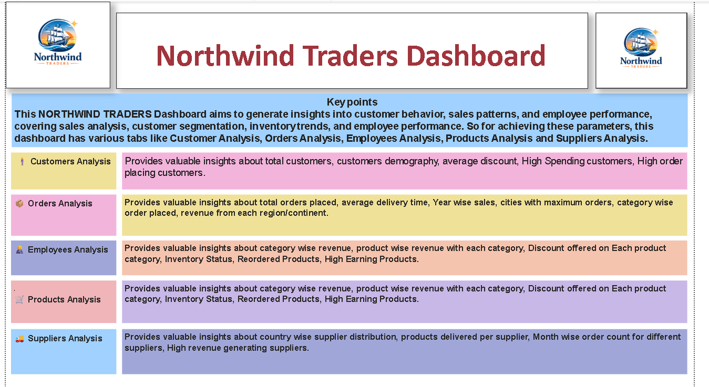

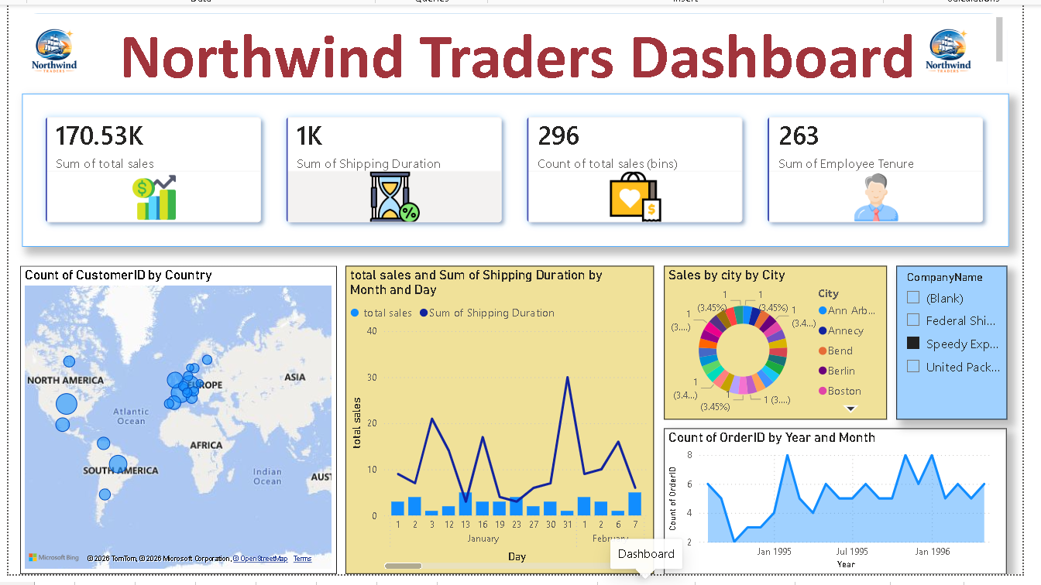
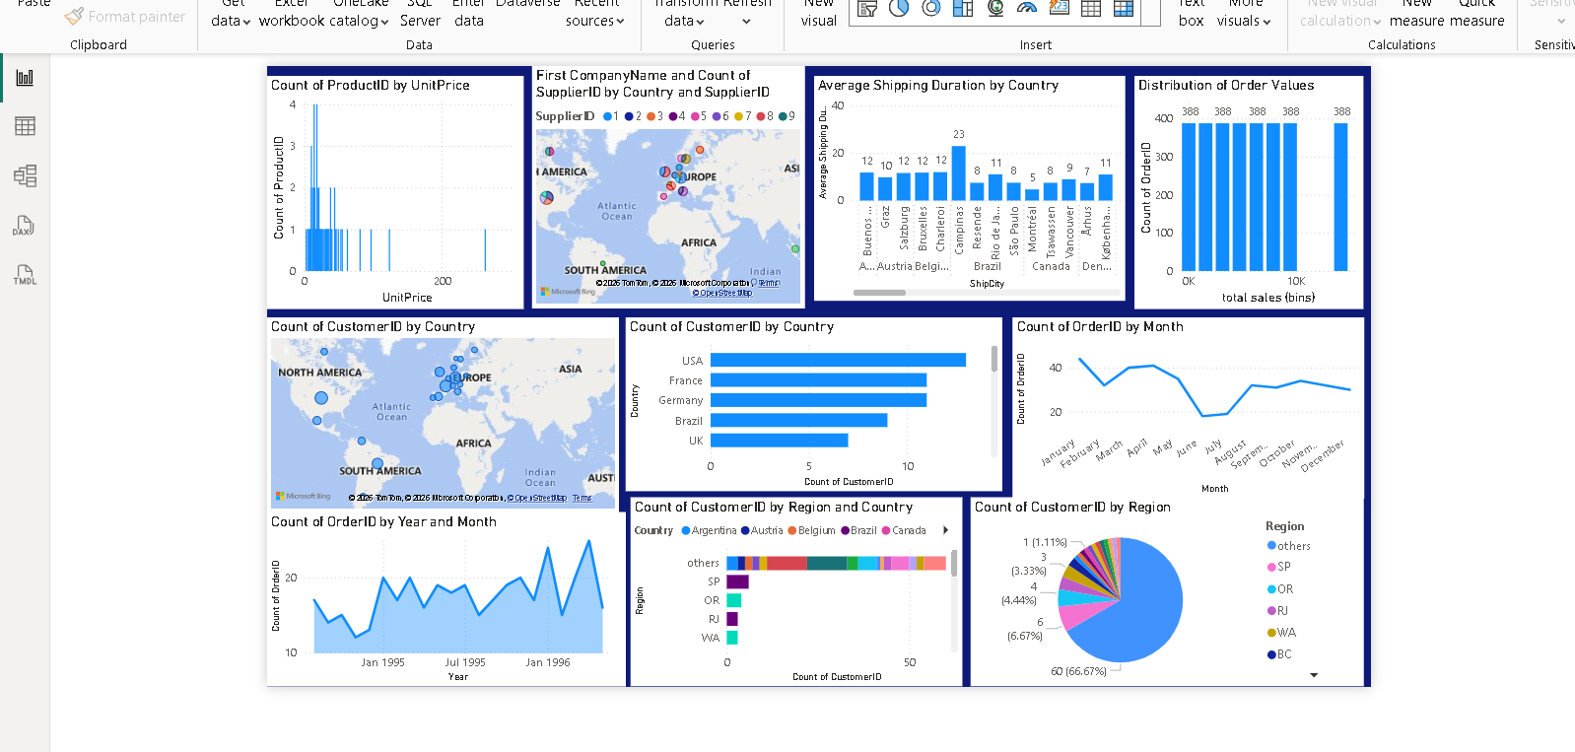

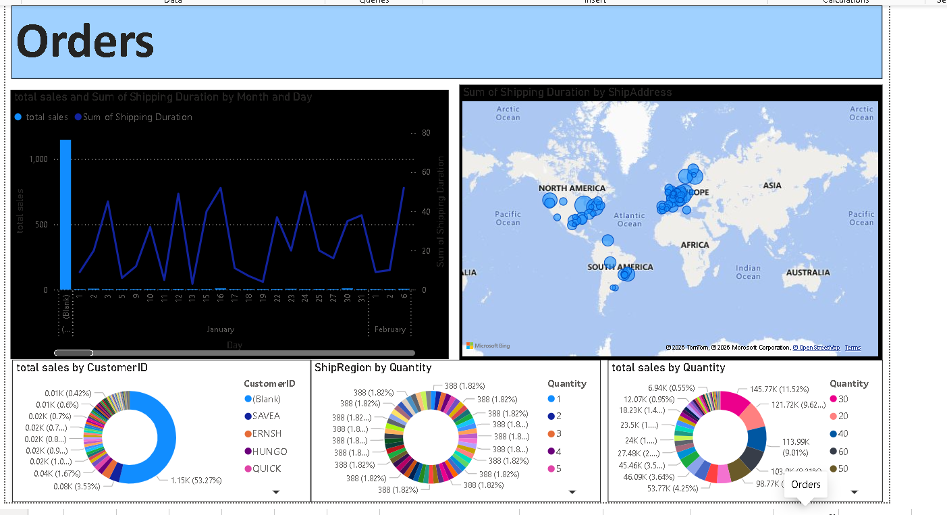
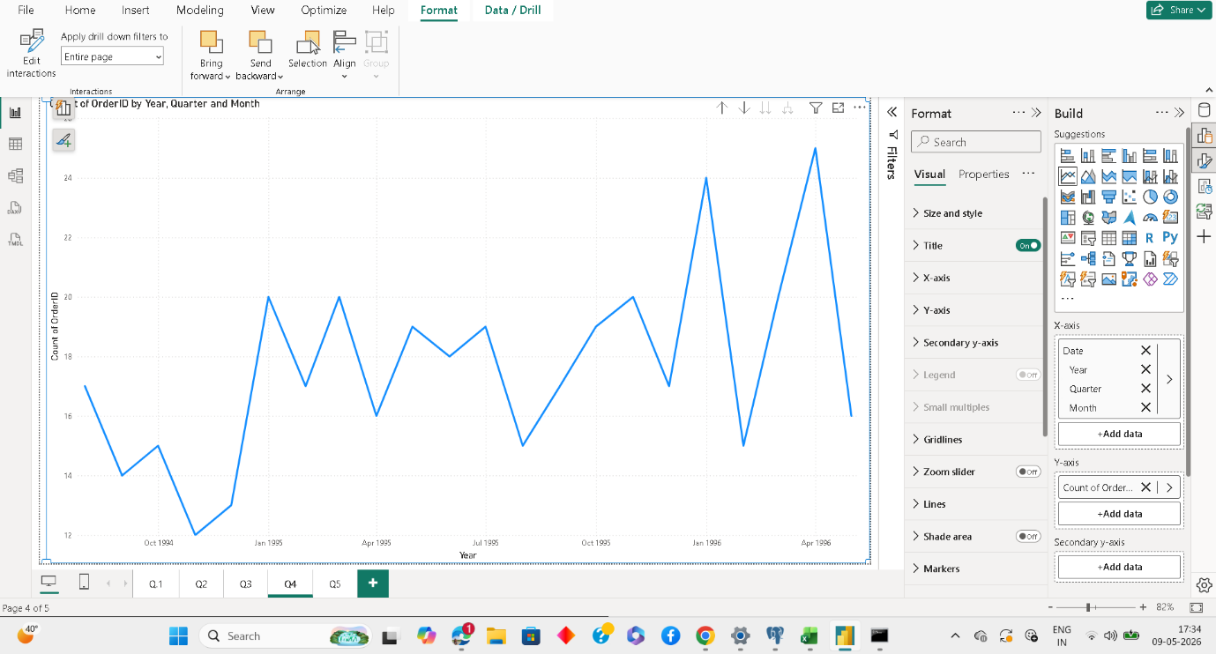

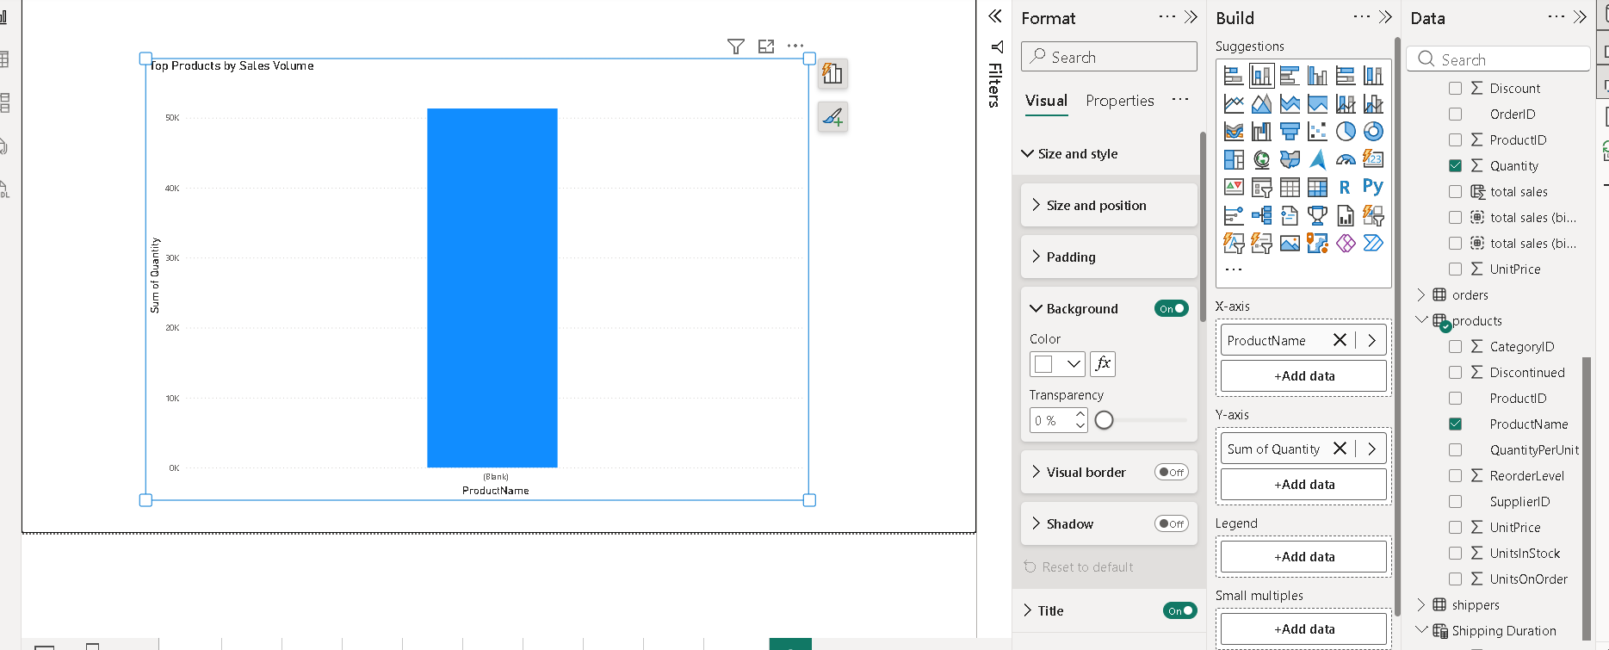

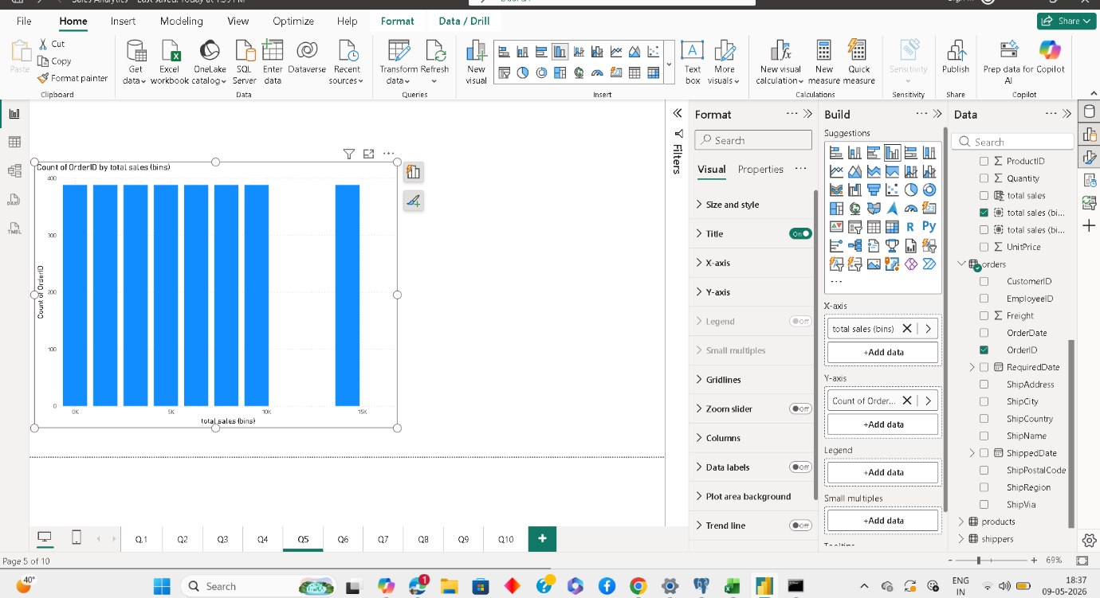

CHAPTER XI

CONCLUSION
The Northwind Traders Dashboard project successfully transformed raw organizational data into meaningful visual insights using SQL, Excel, and Power BI.
The project improved understanding of:
- Sales trends
- Customer behavior
- Product performance
- Operational efficiency
The dashboard supports better decision-making by providing interactive reports and visual analytics.
The project also enhanced practical knowledge in:
- SQL querying
- Data cleaning
- Exploratory Data Analysis
- Dashboard development
- Data visualization

CHAPTER XII

FUTURE SCOPE
Future improvements can include:
- Real-time data integration
- AI-based forecasting
- Predictive analytics
- Mobile dashboard optimization
- Advanced customer segmentation
- Cloud database integration

REFERENCES

- Microsoft Power BI Documentation
- SQL Documentation
- Microsoft Excel Documentation
- Northwind Traders Dataset
- Microsoft Learn Platform
- Business Intelligence Research Papers

